|  |
| --- |
| GE tagline.jpg  ***Global Professional Services*** |
| “Bringing to life GE Intelligent Platforms solutions, utilizing extensive experience, expertise, and capabilities, while following a disciplined and structured set of processes, helping our customers to achieve their business objectives.” |
| Configuration Management – GE GS MES |
|  |
| |  |  | | --- | --- | | Customer: | GE Industrial Solutions | | Location: |  | | Project: | GE Grid Solutions – Brilliant Factory | | Project #: | PUSAL00268 | |
|  |

All rights reserved. No part of this document may be reproduced, stored in a retrieval system, translated or transmitted in any form or by any means, electronic, mechanical, photocopying, recording, or otherwise, without the prior written permission of GE Intelligent Platforms, 2500 Austin Drive, Charlottesville, VA, 22911, USA.

**Confidentiality**

The information contained herein is confidential and proprietary to GE Intelligent Platforms. It may not be disclosed or transferred, directly or indirectly, to any third party without the explicit written permission of GE Intelligent Platforms.**Document Revision History**

|  |  |  |  |
| --- | --- | --- | --- |
| Version | Date | Author | Summary of Update |
| 1.0 | 09-Jun-15 | Ganesh K Ramakrishnan | Initial Release |
| 2.0 | August 12 | Balaji Lakshmanan | Added the PM Add on and SSRS items |
| 2.1 | 17-Aug-16 | Ganesh K Ramakrishnan | Updated for IDAutomation and SSRS |
| 2.2 | 30-Aug-2016 | Ganesh K Ramakrishnan | Updated for Browser settings |
| 2.3 | 15-Feb-2017 | Eric Garcia | Updated Equipment and Personnel Models for new classes |
| 2.4 | 6-Apr-17 | Eric Garcia | Updated Equipment and Personnel Models for new classes, added information about new Activities in Qualification Management and Group Permissions |

**Contributors**

|  |  |
| --- | --- |
| Name | Organization |
| Balaji Lakshmanan | GE Intelligent Platforms |
| Ganesh Ramakrishnan | GE Intelligent Platforms |
|  |  |
|  |  |

**Table of Contents**

Introduction 6

Purpose 6

Audience 6

1. Source Control / Deployment Methodology 7

2. Tools 8

3. SVN repository structure 8

4. Proficy Deployment Process 8

4.1. Deploy DB Objects 8

On incremental deployment 8

4.2. Setup Scheduled Job to deploy services 9

4.3. Setup ProficyServer.exe.config 9

4.4. Deploy ProductOptions 9

4.5. Deploy Proficy Imports 10

4.6. Configurations 11

4.6.1. Equipment Model 11

4.6.2. Personnel Model 13

4.6.3. Document Types 14

4.6.4. Custom Data Types 16

4.6.5. Non Conformance Property 16

4.6.6. Execution Statuses 16

4.6.7. Quality Variables 16

4.6.8. PFMD Settings 16

4.7. Setup IDAutomation for SSRS 24

4.8. Deploy Reports 25

4.9. Data Scripts 26

4.10. Fonts 26

4.11. Browser Settings 26

1.1. PM Add On UCC Thingworx Website 29

1.1.1. Obtain the latest build 30

1.1.2. Deploy the zip file package to Thingworx server 30

1.1.3. SSRS URL Fix inside the PM Add on thingworx 33

1.1.4. Obtain the latest build 34

For operator group 35

1.1.5. Help files fix 36

1.1.6. Report Server URL for the Thingworx 36

2.1.1. The FORM LOGIN for the Operators and GE GS users Thingworx 38

1.1. Integration Configuration Check List 39

# Introduction

## Purpose

This document will be used to build and deploy the MES solution for GE Grid Solutions.

## Audience

Members of the GEIP and GE GS Project Team.

# Source Control / Deployment Methodology

|  |  |  |
| --- | --- | --- |
| Component Type | Source Control | Deployment |
| Proficy Workflow Components, ProficyModels, Classes etc | * Lead exports the objects using Proficy Packager utility. | * Check out the objects from SVN * Imports the objects into target Proficy environment using Excel. * Tags the environment, build #, date in SVN |
| Proficy Service Providers, Proficy Activities | * Lead checks in the pf files to SVN | * Lead checks out the objects. * Deploys the service provider to target Proficy Server * Tags the environment, build #, date in SVN. |
| Silverlight, WCF, Other .NET assemblies | * Developer * checks in the solution files to SVN | * Lead checks out the objects * Builds the .NET assemblies * Deploys the assembles to target server. * Tags the environment, build #, date in SVN. |
| Database Objects | * Lead extracts the SQL and checks in the scripts to SVN | * Lead checks out the objects * Runs the scripts in target Database environment * Tags the environment, build #, date in SVN |
| Other files (config/ data imports etc), these are environment specific | * Development /Lead gather the data / files. * Lead checks into SVN and tags the environment, build #, date. | * Lead checks out the objects * Lead deploys to target system. |

# Tools

* SVN (openge) will be used as the source control repository.
* Tortoise SVN client will be used to check in/out from the repository.
* Excel 2010 will need to be installed in the Proficy Server to do exports & imports.
* SQL server management studio will be used to run the sql scripts

# SVN repository structure

* Trunk\Build will be the main directory that will hold the latest build
* Tags will be used to track deployment.

# Proficy Deployment Process

The following section outlines the steps that should be taken to deploy various components of the FAA System.

## Deploy DB Objects

1. The following steps are done from a machine that can connect to the database
2. Get the files from SVN

* \trunk\Build\SQLScripts
* \trunk\Build\Scripts

1. Edit the GEDS_SOADB.bat and specify the correct DB Credentials
2. Execute GEDS_SOADB.bat
3. Just 2 Files for Stored procedure execution
   1. One is the SQL with all the stored procedure scripts
   2. And one batch file to execute it as below
   3. Just double click the Batch file

## On incremental deployment

For generate the Stored Procedures, first do the Generate_LocalSP.SQL

Generate the new Scripts_StoredProcedure_DropANDCreate.SQL first

Then do the following



## Setup Scheduled Job to deploy services

**Note:** One time setup

Crate a Windows scheduled task, make it run as the same account running the Proficy service, point it to run the script “\trunk\Build\Scripts\GEDS_Install_PF.bat”

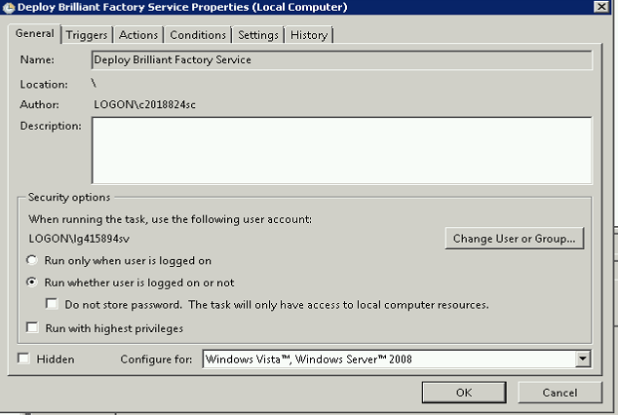

## Setup ProficyServer.exe.config

Note : Refer to sample in \Build\Config – Not Applicable for now

1. The following steps are done in the Proficy Server
2. Stop the Proficy Server
3. Open the ProficyServer.exe.config file and make the following changes, do both 32 and 64 bit.
4. In ProficyServer.exe.config Increase the setting for MaxMessageSize to 2147483647
5. Start the service

## Deploy ProductOptions

1. The following steps are done in the Proficy Server
2. Make sure no one is using the Proficy Client
3. Stop “Proficy Server” service
4. Copy the new product Option files from SVN to ProductOptions Folder under Proficy (for example: D***:\Program Files (x86)\Proficy\Proficy Workflow\Program\ProductOptions***)
   1. \trunk\Build\ProductOptions
5. Delete ProficyServer.log file
6. Run the scheduled job “Deploy Brilliant Factory Service”
7. Get \trunk\Build\Scripts\GEDS_ConfigureSite.bat [verify the credentials to be using same as Proficy server process]
8. Run it and enter the password when it prompts.

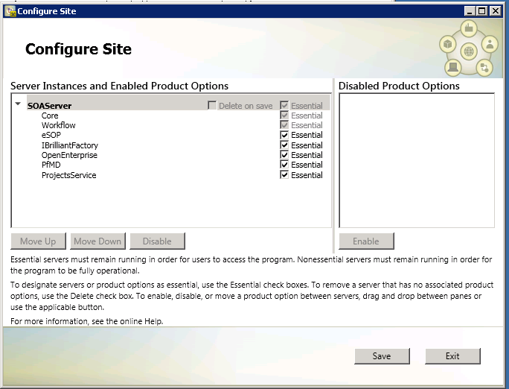

1. Start “Proficy Server” service if not already started.
   1. Note: If Proficy Server would not start, run the script GEDS_ProficyServer.bat, type in the service password and type Y when prompted to update Product Options, follow the prompt .
   2. Once done , start the “Proficy Server” service.

## Deploy Proficy Imports

1. The following steps are done in the Proficy Server
2. Do this only for first deployment
   1. Extract the zip file \trunk\Build\Exports\GEDS_OneTime_Package.zip to a local folder
   2. Log into Proficy Client using admin
   3. Import the objects under each folder, follow in the same numbering of the folder
3. Extract the zip file \trunk\Build\Exports\GEDS_Package.zip to a local folder
4. Log into Proficy Client using admin
5. Import the objects under each folder, follow in the same numbering of the folder

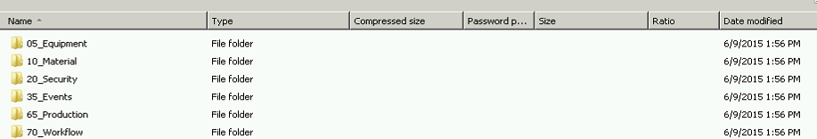

1. Go to Database Connection SOADB and give correct credentials
   1. 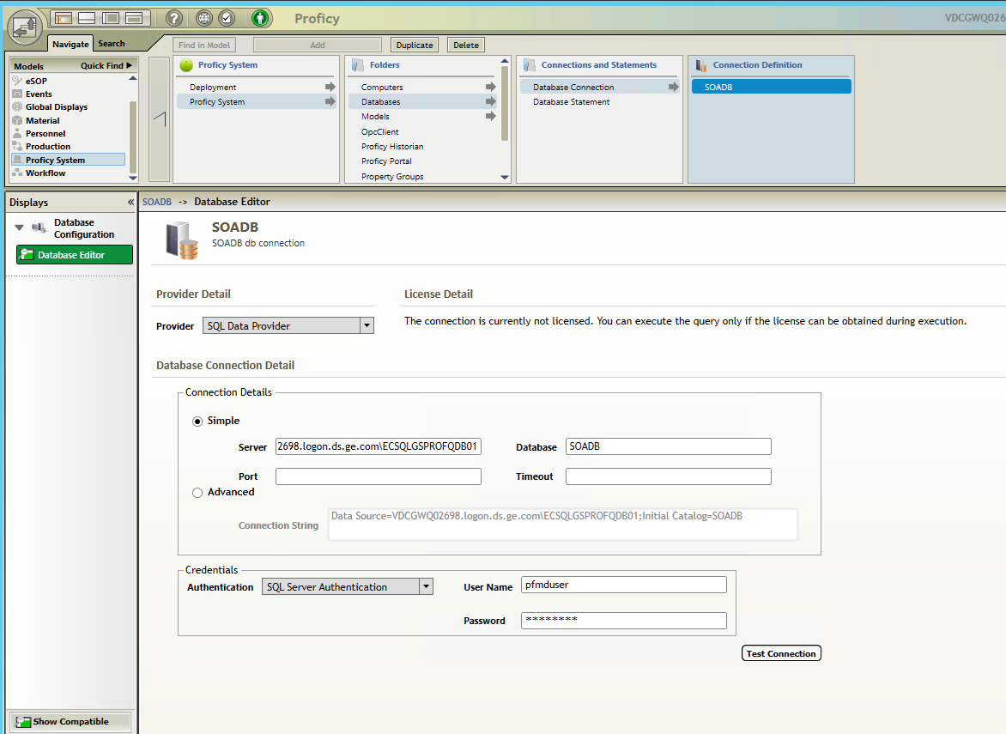
2. Go through the Workflows, enable them.
3. Go through the Events enable them.
4. Go through the Schedules enable them.

## Configurations

### Equipment Model

Setup the equipment\assign classes as per the hierarchy defined in the

\svn\gegridsolmes\ProjectDocs\DP1 Solution Generation and Validation\DetailedDesign\Model\GEDS_Model.vsd

**Enterprise**

Add the “GEDS_Global_Configuration” to the “Enterprise” and set the following values

|  |  |  |
| --- | --- | --- |
| **Property Name** | **Value** | **Notes** |
|  |  |  |

**Site**

Add the “GEDS_Site_Configuration”, “GEDS_Site” to the “Site” and set the following value

|  |  |  |
| --- | --- | --- |
| **Property Name** | **Value** | **Notes** |
| GEDS_ERP_ORG_Code | OU_C86085_US | ERP Org code used for the site |
| TimezoneName | GMT-5 | Used by UI to show date/time in proper timezone for users |
| TimezoneName_PFMD | Eastern Standard Time | Used by PFMD Service Provider to convert date/time to/from UTC properly |

**Area**

|  |  |  |
| --- | --- | --- |
| **Property Name** | **Value** | **Notes** |
|  |  |  |

Production Line Properties

Add the “GEDS_ProductionLine”, “PFM_ProductionLine” to the “Line” and set the following value

|  |  |  |
| --- | --- | --- |
| **Property Name** | **Value** | **Notes** |
| GEDS_Is_AutoRelease | True | Set this to True if we need to auto release the shop orders to the floor |
| GEDS_Line_Category |  | Used in route interface to find the line based on category sent from ERP  Leave blank if not setting multiple lines by category |
| GEDS_Product_Category |  | Used in Item Master interface to find lines for documents  Leave blank if not setting multiple lines by product category |
| GEDS_IsRoute_AutoRelease | True | Set this to True if we need to auto release the routes onto the floor |

Workstation Properties

Add the “GEDS_WorkStation”, “PFM_WorkStation”, “PFM_Machine”, “PLM_Equipment” to the “Workstations” and set the following value

|  |  |  |
| --- | --- | --- |
| **Property Name** | **Value** | **Notes** |
| IsBatchStation | False | Allows Batches for Workstation |

### Personnel Model

Create a new user “GEDSSystem”, give the user the following groups. Note: do not give administrator rights for this user.

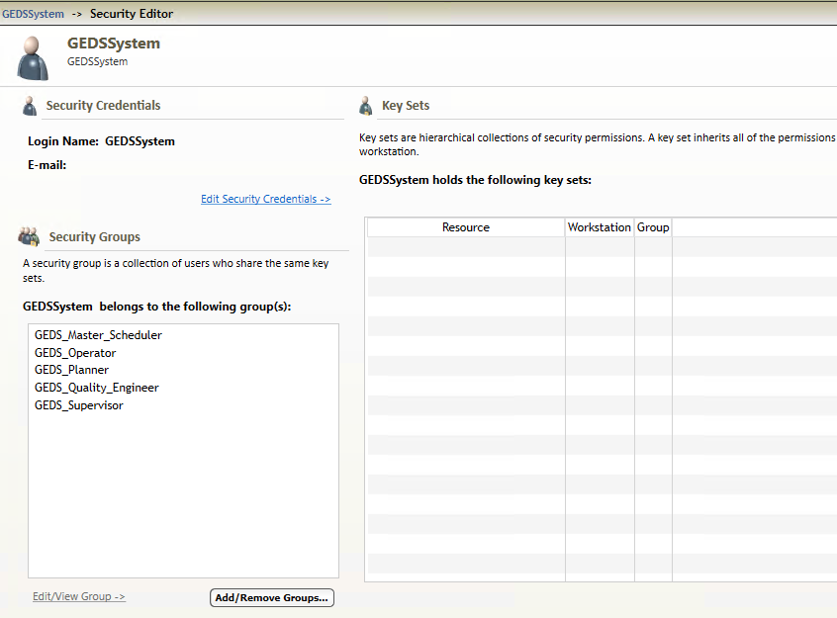

**User**

Add the “GEDS_User” to each User and set the following value

|  |  |  |
| --- | --- | --- |
| **Property Name** | **Value** | **Notes** |
| CountryCode | .us | Used by UI to show country related content (i.e. text orientation) |
| LanguageCode | en-US | Used by UI to show labels in the proper language for the user |

### Document Types

Note: Document Management must use SOADB as repository.

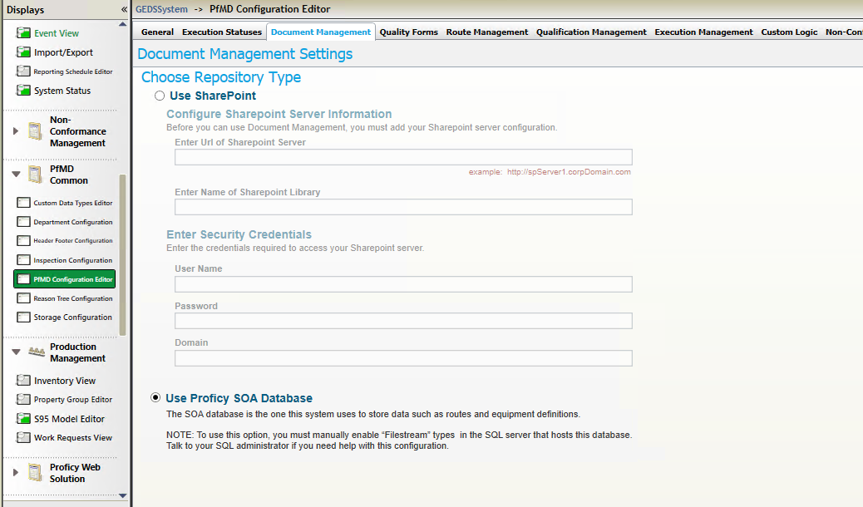

Add the following document types

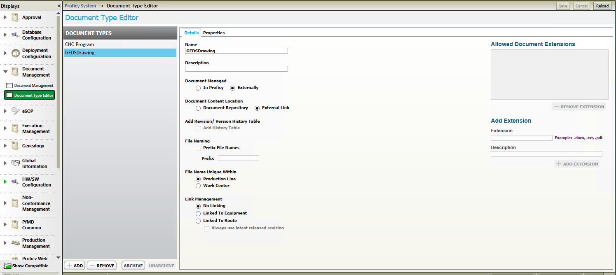

### Custom Data Types

Add the following custom data types

### Non Conformance Property

Add the following NonConformance property

### Execution Statuses

### Quality Variables

### PFMD Settings

* Set Document Management to use SOADB

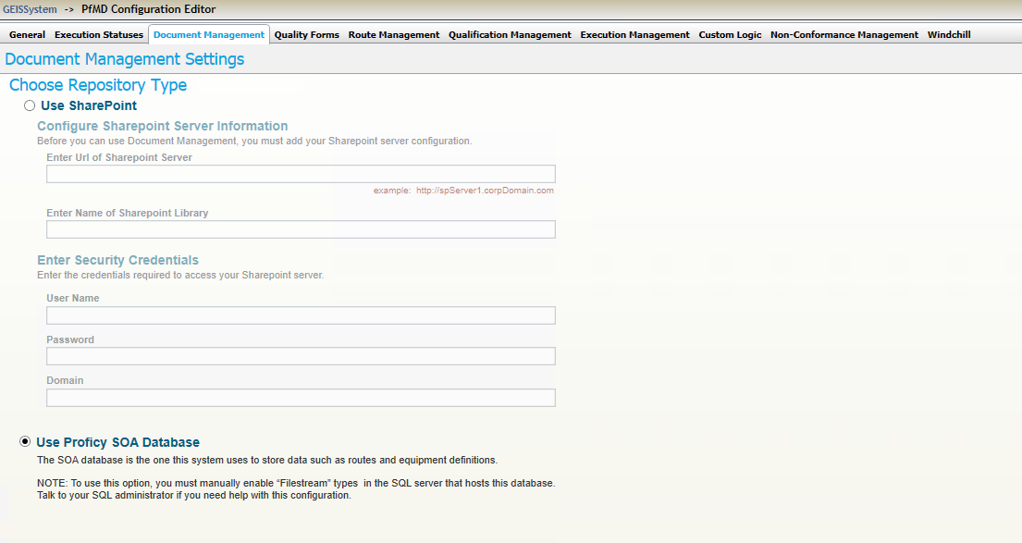

* Route Management settings

Set the master\operation\step process segments to use GEIS Process segments as shown below.

Set the correct data types for the properties.

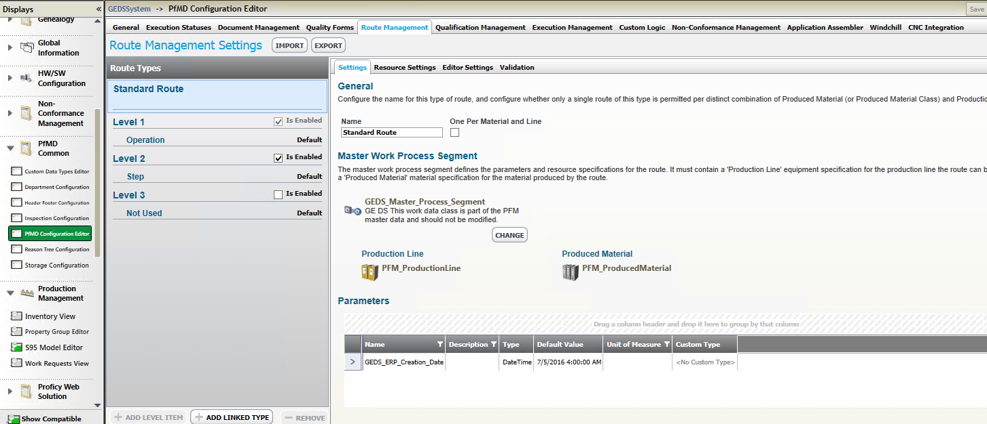

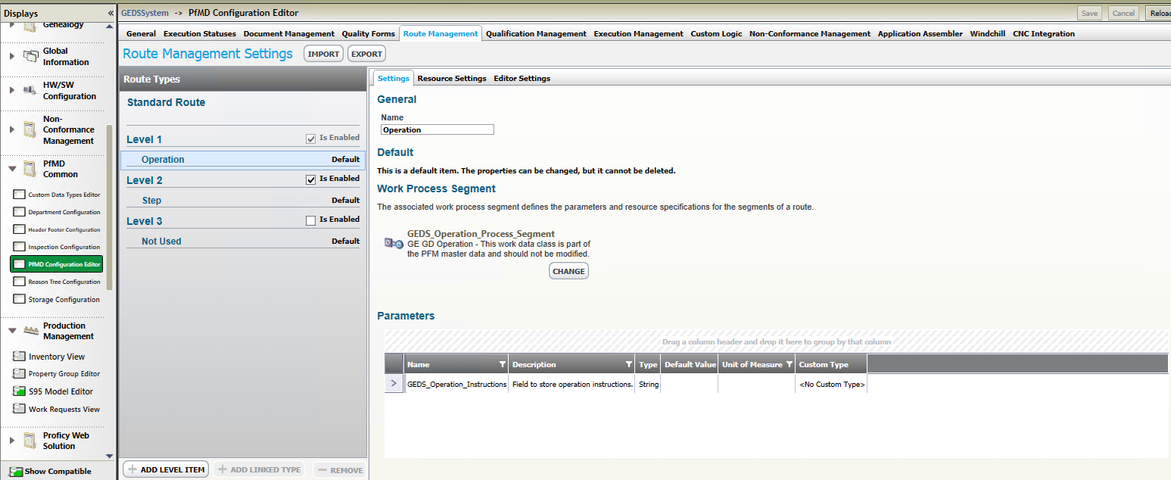

* Import D:\GEGridMES\Build\Config\RouteConfig.xml from the Route Management settings tab.

**Qualification Management – Activities**

Create GEDS_APP and GEDS_ResourceAssociation categories with the following sub-activities:

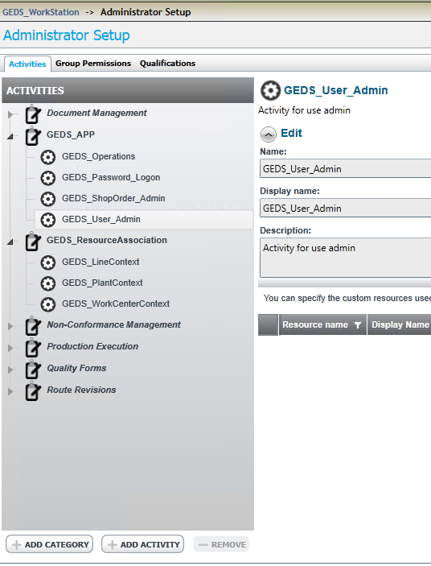

**Qualification Management – Group Permissions**

GEDS_Operator – Add GEDS_Password_Logon, and GEDS_WorkCenterContext activities along with permissions shown in screenshot

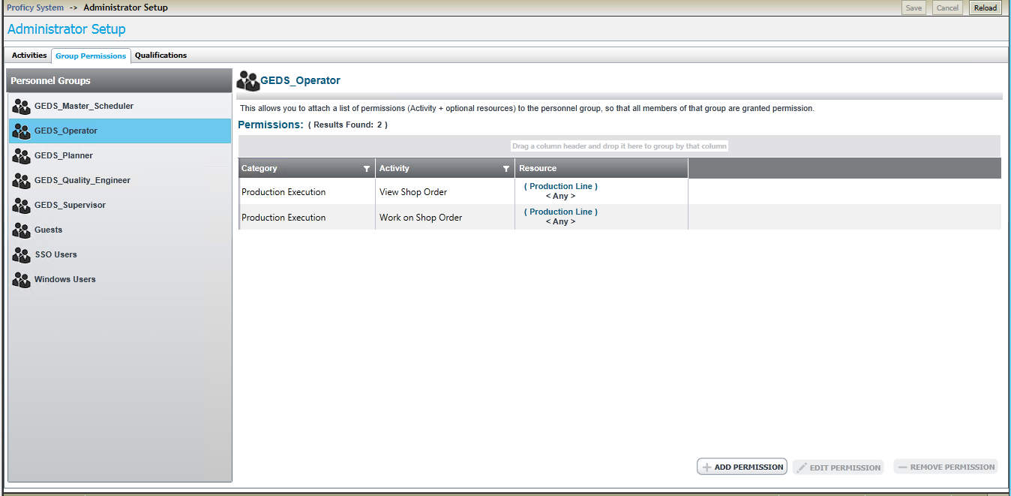

GEDS_Planner – all permissions under Document Management, Route Management, Production Execution, Non Conformance. Also add GEDS_Password_Logon, GEDS_ShopOrder_Admin, GEDS_User_Admin, and GEDS_LineContext activities.

GEDS_Supervisor – all permissions under Document Management, Route Management, Production Execution, Non Conformance. Also add GEDS_Password_Logon, GEDS_ShopOrder_Admin, GEDS_User_Admin, and GEDS_LineContext activities.

GEDS_Master_Scheduler - all permissions under Document Management, Route Management, Production Execution, Non Conformance. Also add GEDS_Password_Logon, GEDS_ShopOrder_Admin, and GEDS_LineContext activities.

GEDS_Plant_Administrator - Add GEDS_Password_Logon, GEDS_ShopOrder_Admin, GEDS_User_Admin, and GEDS_PlantContext activities.

GEDS_Quality_Engineer

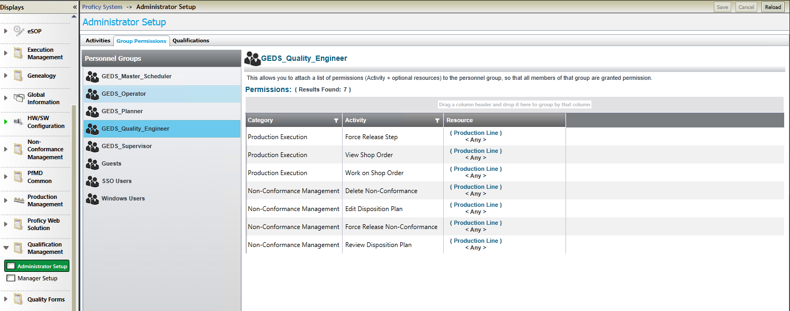

#### Proficy System / Computer / HW

This below screen needs to be checked (check box enabled) for all the computers, in the future if the new clients or new computers are added this check box needs to be enabled again.

We need to comeback to this and do it again for each client added

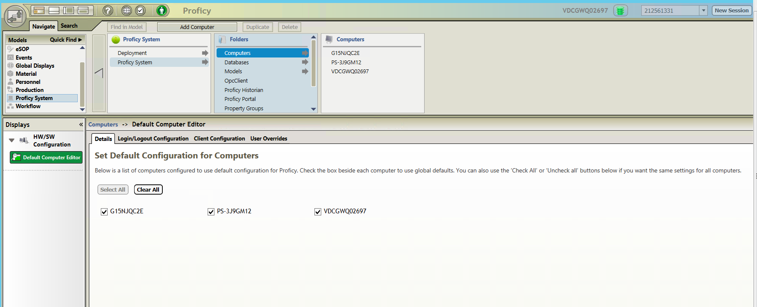

1. For “GEDS_Planner”, “GEDS_Master_Scheduler” add “System Visibility” to all work stations for Execution Management, Genealogy Viewer, WIP Display

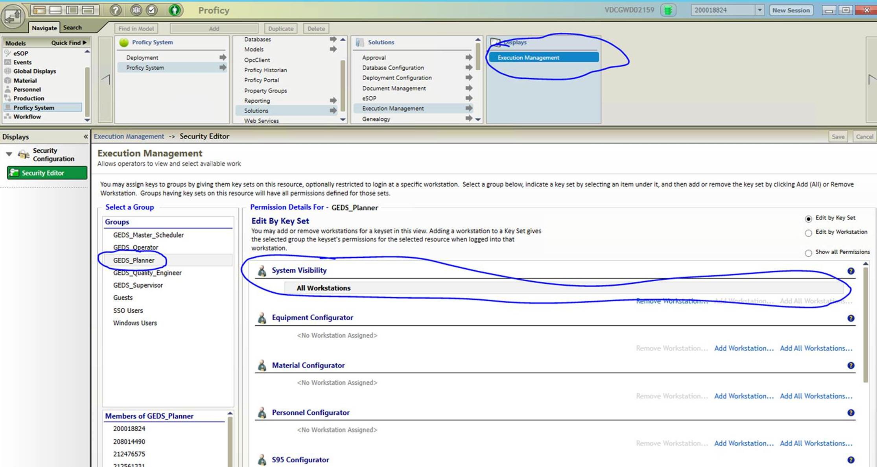

1. Turn off the solution panel for all computers and set the starting point to Execution Management

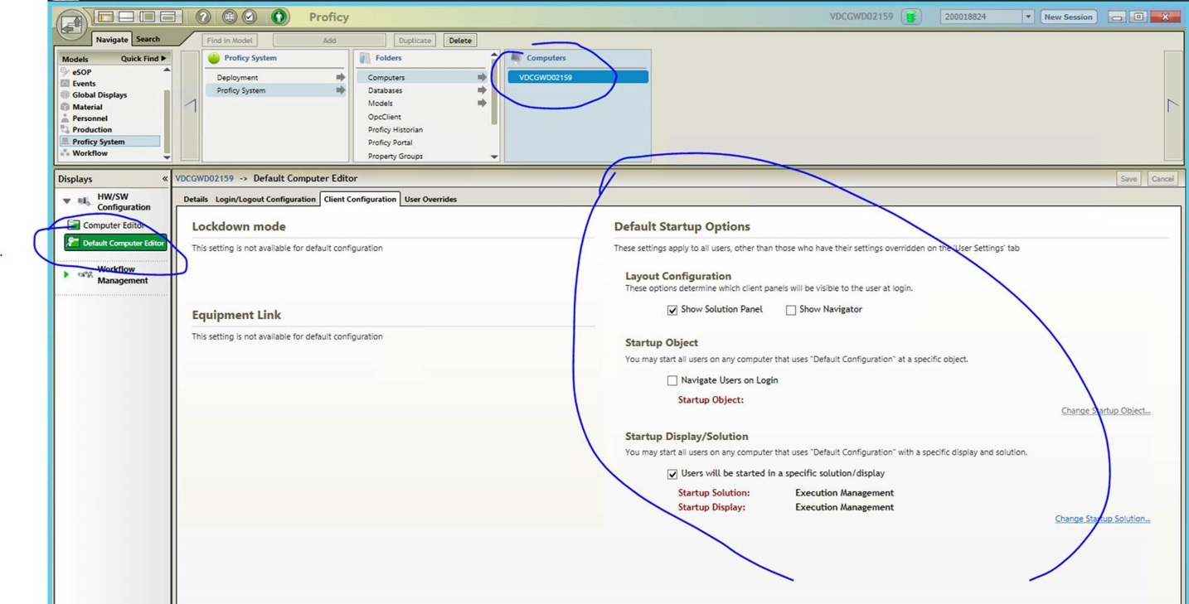

1. Most Important: for Administrators set user overrides to show the soln panel.. once this is saved.
2. Without closing the current session…

Start new proficy client sessions and login with admin to make sure the solution panels show up.

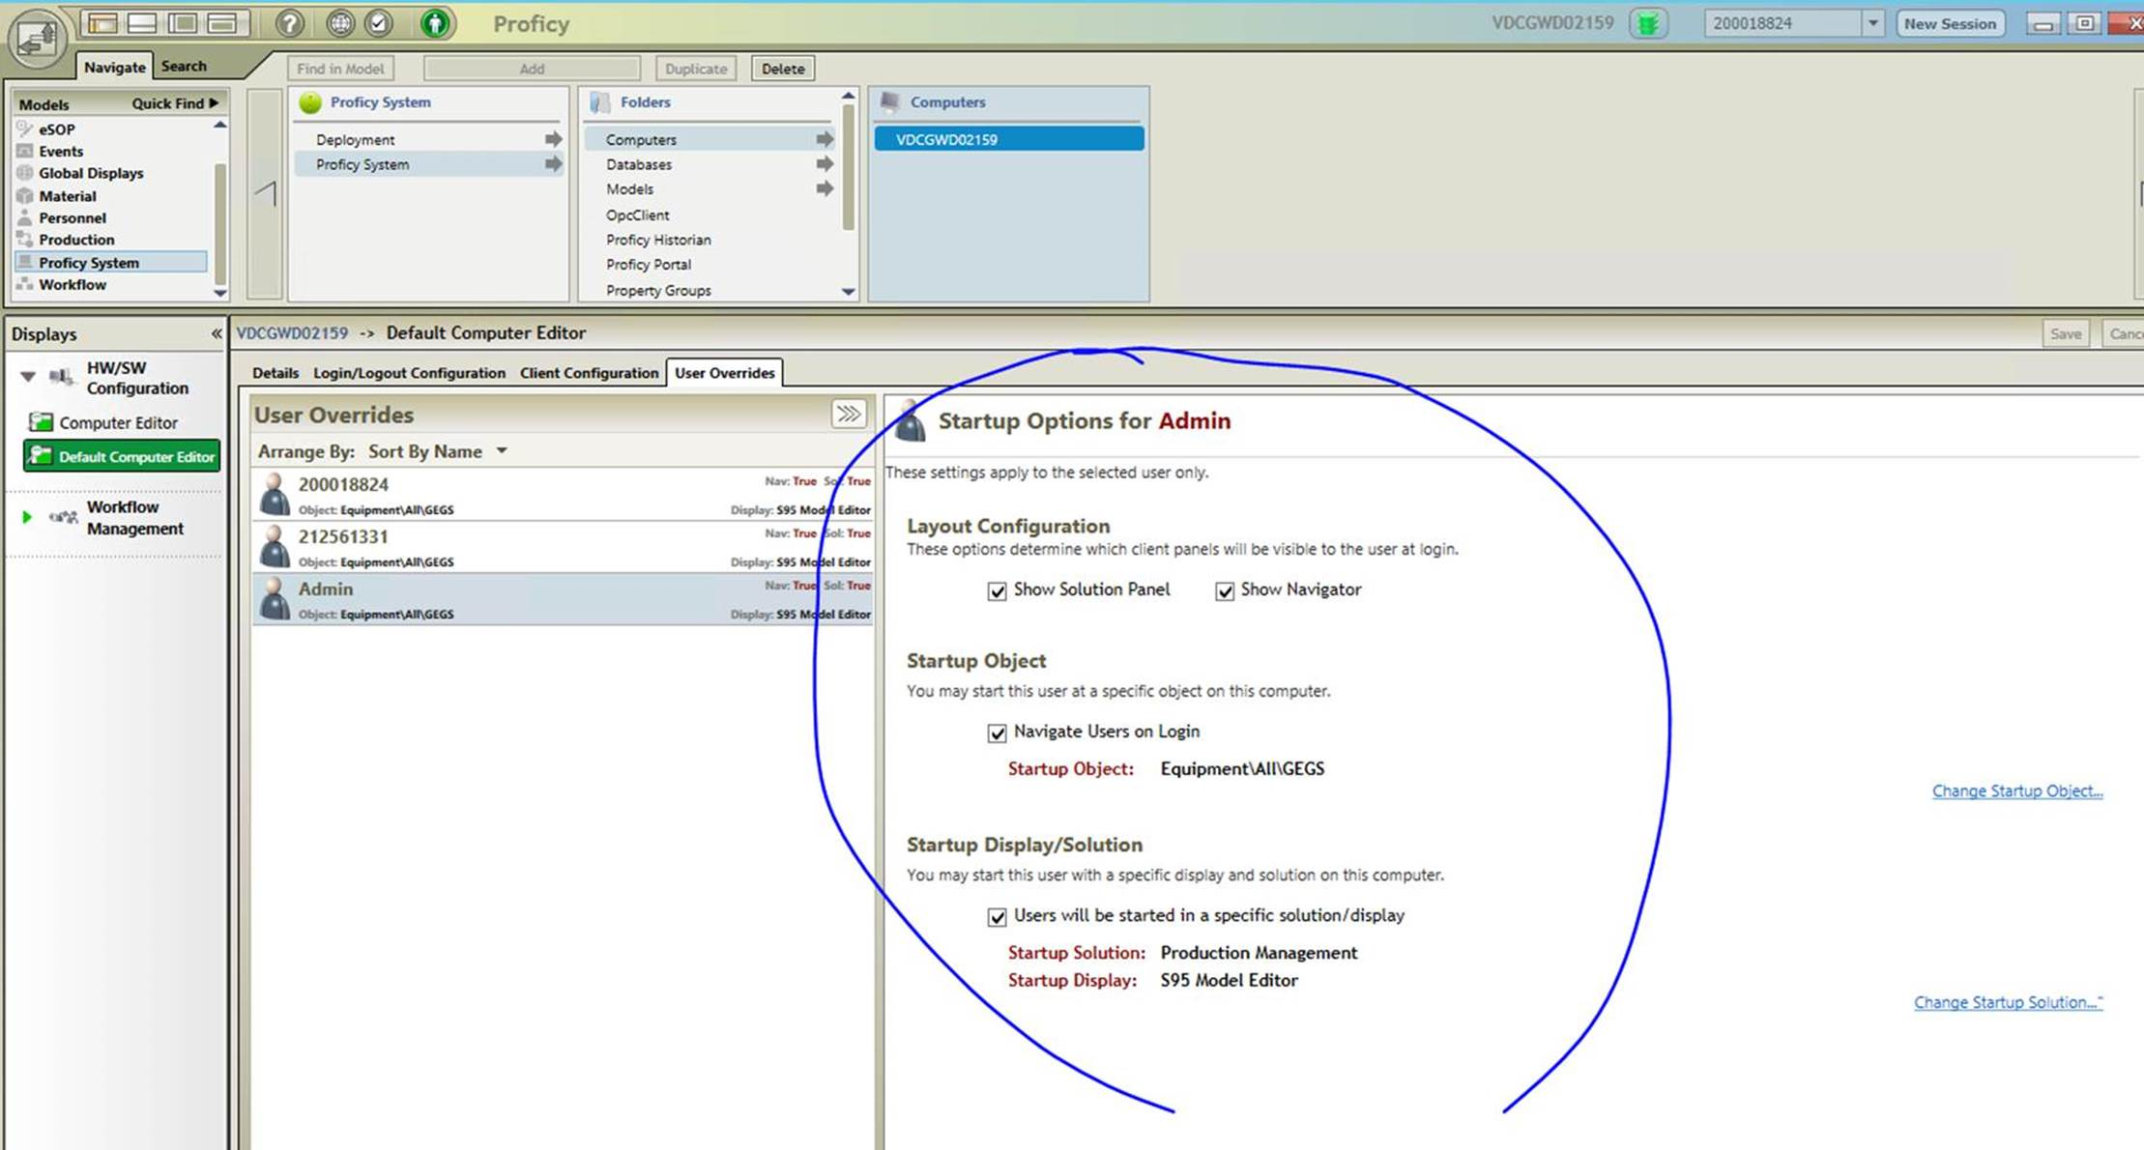

Also do this check box enable them for all the computers and save them

Machine generated alternative text:
Navigate Seuch 
Quick Find 
SOP 
Global Displays 
a 
Material 
Personnel 
Production 
Displays 
HW/SW 
Configuration 
Default Computer Editor 
o 
Find in Model 
Proficy System 
Deployment 
Proficy System 
Proficy 
Add Computer 
Duplicate 
Folders 
Computers 
Databases 
Models 
OpcClient 
Proficy Historian 
Proficy Ponal 
Propeny Groups 
Delete 
VDCGWQ02697 
Computers 
Gl 5NJQC2E 
PS-3J9GM12 
VDCGWQ02697 
212561331 
New Session 
Computers o Default Computer Editor 
Details Login/Logout Configuration Client Configuration user Overrides 
Set Default Configuration for Computers 
Below is a list of computers configured to use default configuration for Proficy. Check the box beside each computer to use global defaults. You can also use the 'Check All' or 'Uncheck all' buttons below if you want the same settings for all computers. 
Select All 
Clear All 
V] G15NJQC2E 
V] PS-3J9GM12 
V] VDCGWQ02697 

#### PFMD Application Assembler

No need as no relation between the PM Add on to the Proficy MES client

Reason Trees

Setup root for Defect Category and Defect Cause

Setup the Non-Conformance cause and defect trees

## Setup IDAutomation for SSRS

1. Remote in to the SSRS server
2. Copy the “IDAutomation2D N5.ttf” from svn\gegridsolmes\trunk\Build\IDAutomation\IDAutomation 2D Fonts\IDAutomation_Universal2DBarcodeFont\PDF417 N=5\TrueType
3. Install the font
4. Find the folder where SSRS is running.
5. For example - H:\SystemDB\ENSQLGSPDN01\components\MSRS11.ENSQLGSPDN01\Reporting Services\ReportServer\bin
6. Copy the “IDAutomation.PDF417.dll” into the folder.
   1. Available in svn at \svn\gegridsolmes\trunk\Build\IDAutomation\IDAutomation PDF417 Developer Tools\Dotnet DLL and Forms Control
7. Edit the “rssrvpolicy.config” file in the “ReportServer” folder
8. Paste the following after the first “CodeGroup” node

<!-- Start IDAutomation -->

<CodeGroup

class="UnionCodeGroup"

version="1"

PermissionSetName="FullTrust"

Description="This code group grants IDAutomationNETAssembly.dll Full Trust permission.">

<IMembershipCondition class="UrlMembershipCondition"version="1"

Url="H:\SystemDB\ENSQLGSPDN01\components\MSRS11.ENSQLGSPDN01\Reporting Services\ReportServer\bin\IDAutomation.PDF417.dll" />

</CodeGroup>

<!-- End IDAutomation -->

1. Also make sure the codegroup “Report_Expressions_Default_Permissions” has FullTrust.
2. Save the file
3. Restart the SSRS services.
4. Remember to Re boot the SQL Server - important

## Deploy Reports

**Note: Do the script deployment only when deploying first time or when deploying a large # of report files.**

For smaller deployments, upload just the changed files manually which will eliminate steps 8 and 9 to be done for all data sets and reports.

1. Connect to SSRS and create the following folders if they don’t exist
   1. DataSources
   2. DataSets
   3. Reports
2. Create a new DataSource called SOADB under the DataSources folder
   1. 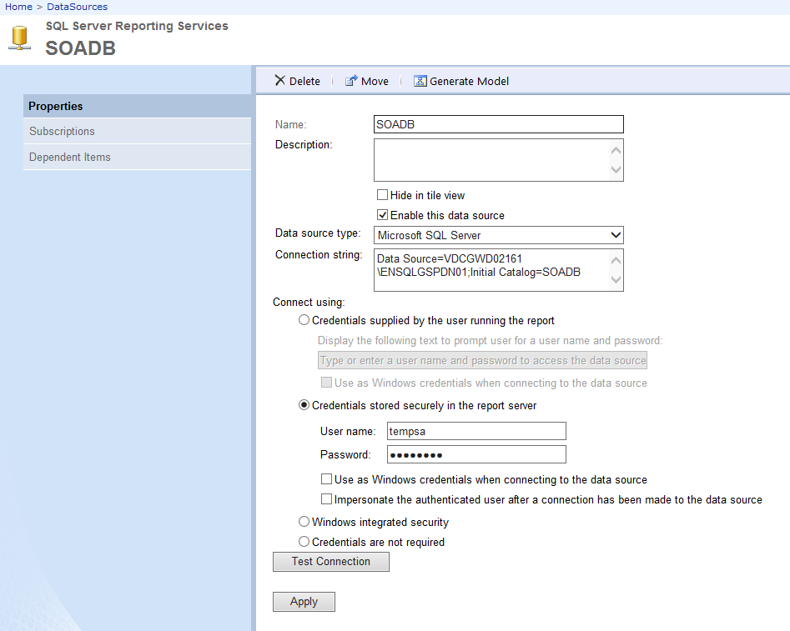
   2. Enter the correct credentials and test connection.
3. The following steps are done on any machine that can publish to the SSRS
4. Get the files from [SVN Path : svn\gegridsolmes\trunk\Build\SSRS_Deploy]
5. Edit the DeployGEDSReports.bat and specify the correct Reportserver URL
6. Edit the DeployGEDSReports.rss, look for the variable ReportSource = adjust this to the local folder where the trunk\Build\Reports is checked out.
7. Execute DeployGEDSReports.bat
8. Go to the SSRS folder, manually wire up the DataSets to corresponding Data Sources
9. Go to the SSRS folder, manually wire up the reports to shared data sets.

## Data Scripts

1. NA as of now
2. The following steps are done from a machine that can connect to the database
3. Get the files from SVN

* \trunk\Build\SQLScripts
* \trunk\Build\Scripts

1. Edit the GEIS_DataScripts.bat and specify the correct DB Credentials
2. Execute GEIS_DataScripts.bat

## Fonts

* Install the Bar Code Fonts for the GE Grid Solutions SSRS Project

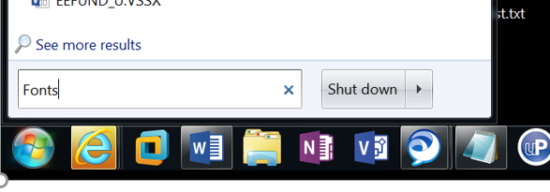

* Font files TTF files are kept in SVN Source Safe
* Get Latest from the SVN folder for the bar code fonts
* C:\gk\svn\gegridsolmes\trunk\Build\IDAutomation\IDAutomation 2D Fonts\IDAutomation_Universal2DBarcodeFont\PDF417 N=5\TrueType
* Drag and Drop “IDAutomation2D N5.ttf” Font to the Fonts Folder

## Browser Settings

In order for Chrome to automatically authenticate to SSRS. Set the security of trusted sites to Low.

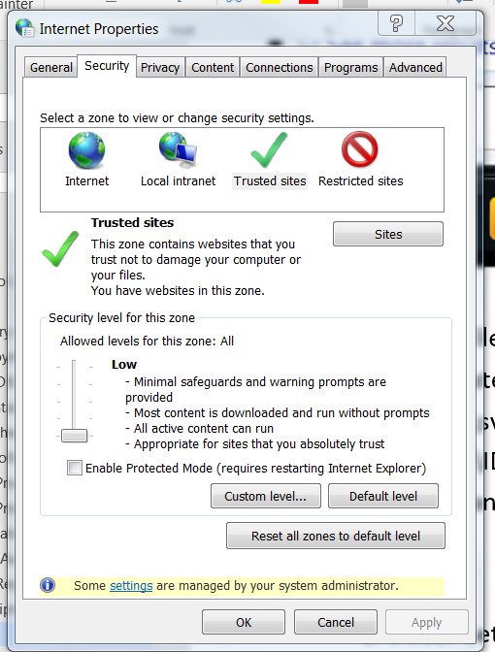

Make sure *.ge.com is in the sites list.

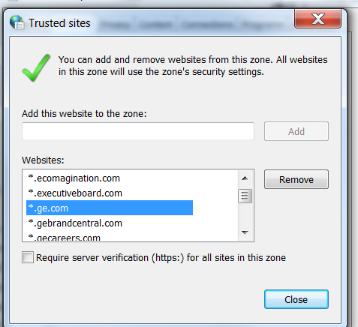

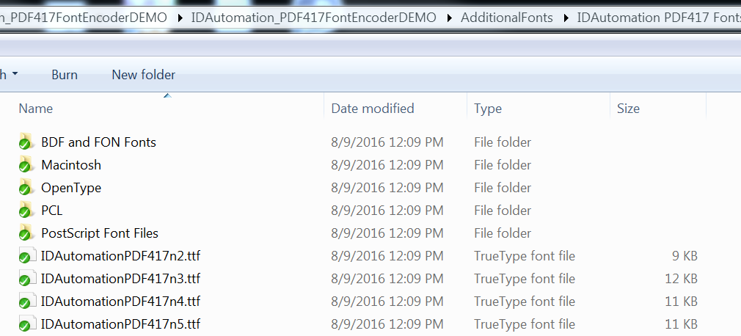

* Go to the Fonts

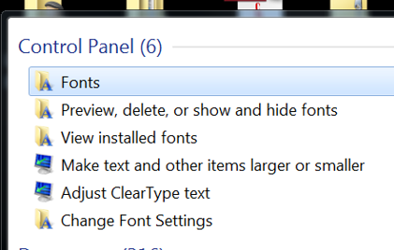

* Drag and Drop the Font Files to here (all the 4 of them)

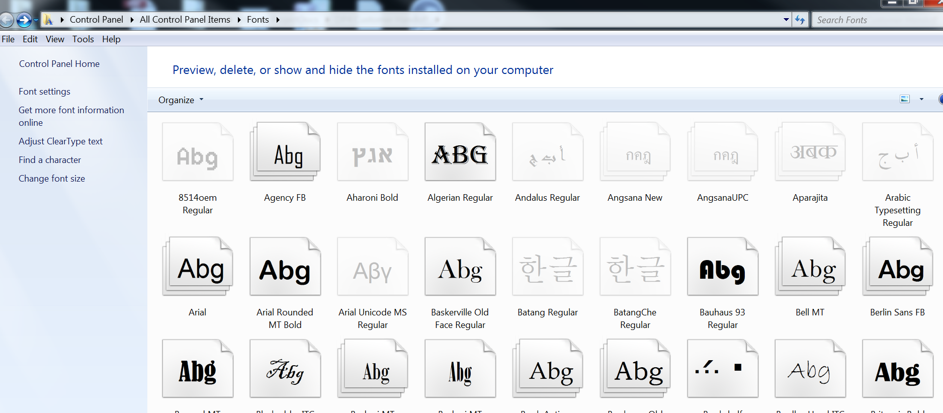

## PM Add On UCC Thingworx Website

Get in to the Bamboo plan for GE Grid Solutions

Build projects 🡺 PFM Solutions 🡺 GridSol-PFMSOL-PM

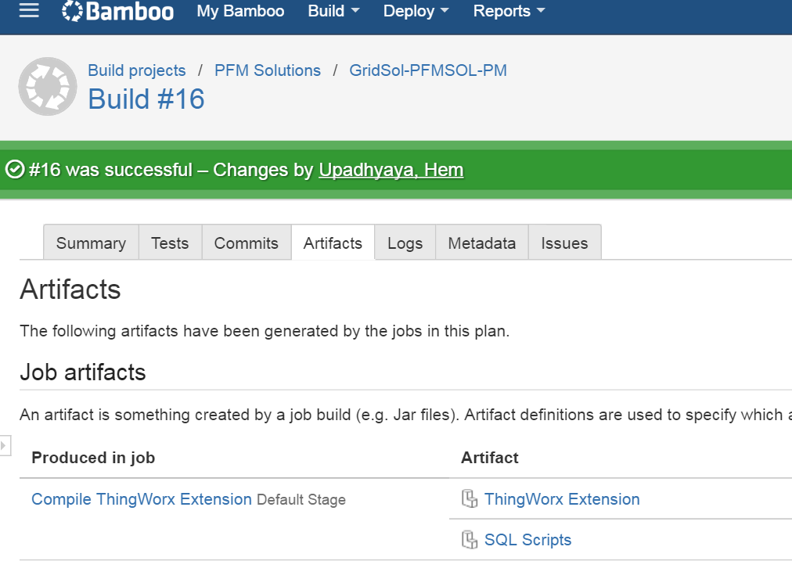

### Obtain the latest build

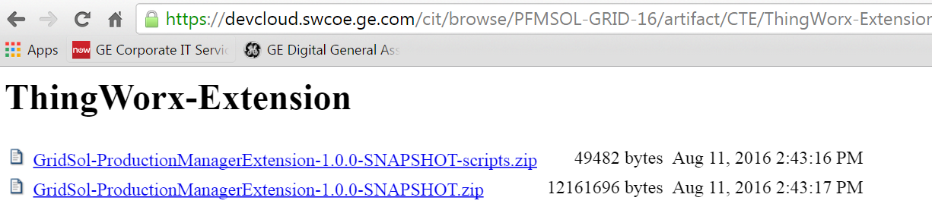

Download the Zip file without the script, get the one with just the SNAPSHOT.zip and keep it ready.

### Deploy the zip file package to Thingworx server

Remove the existing GridSol ProductionManagerExtension extension from the Import / Export Screen

#### Go to Import/Export

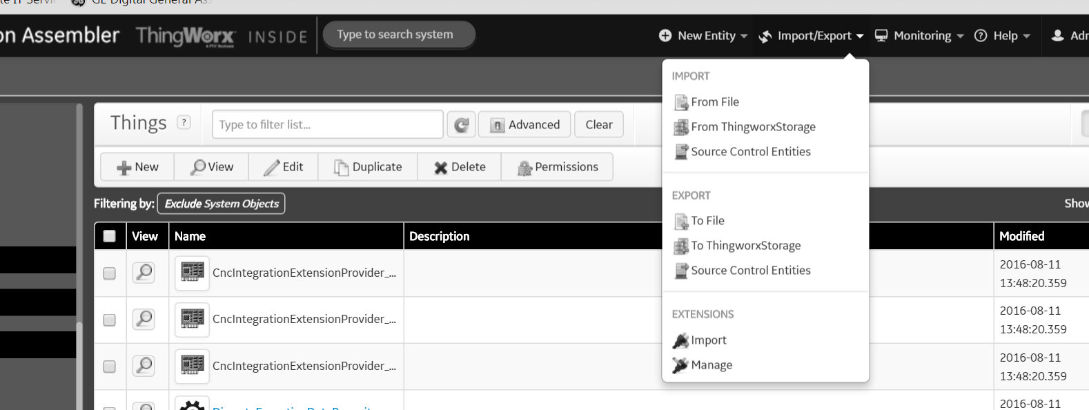

If there is an out of box ProductionManagerExtension extension delete it

Delete Extension - ProductionManagerExtension

#### Delete Extension - GridSol ProductionManagerExtension

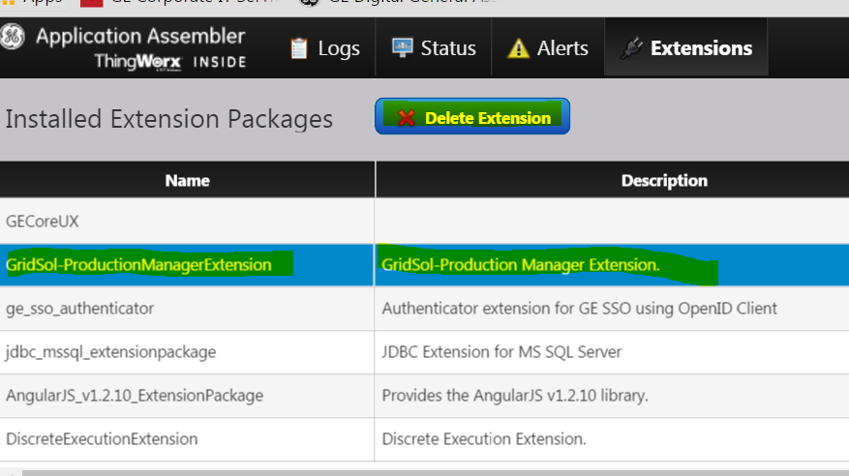

#### Go to the Import and select the new Zip file and import it

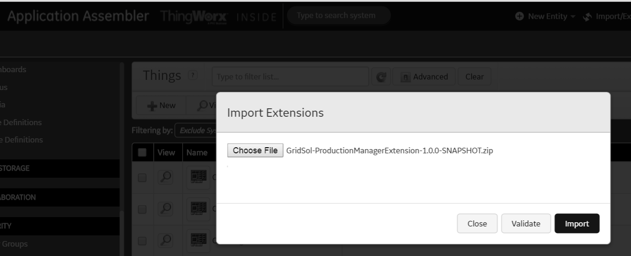

* Might take some time to import
* Will validate first and will do the import later
* Wait
* Close it and it will ask for Refresh

Go to Import and Manage and verify the Version number

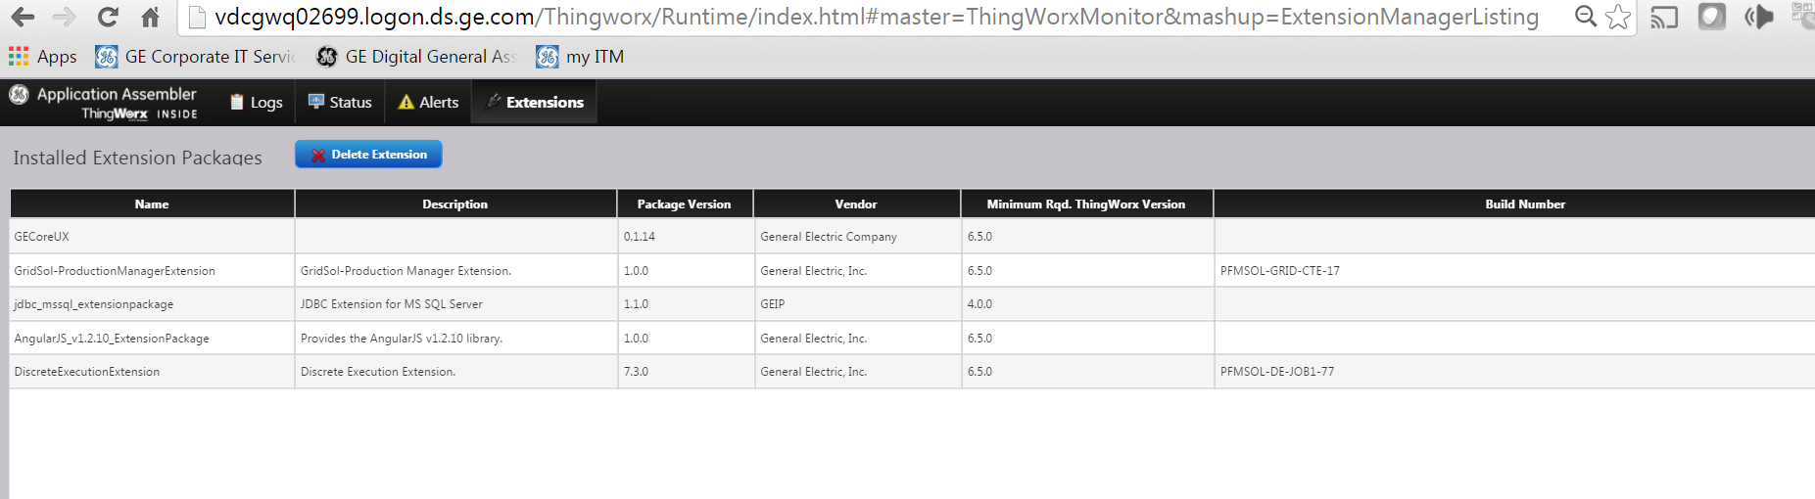

#### Fix the JDBC to point to the QA SQL Database

Go to the DiscreteExecutionDataRepository thing and select the configuration

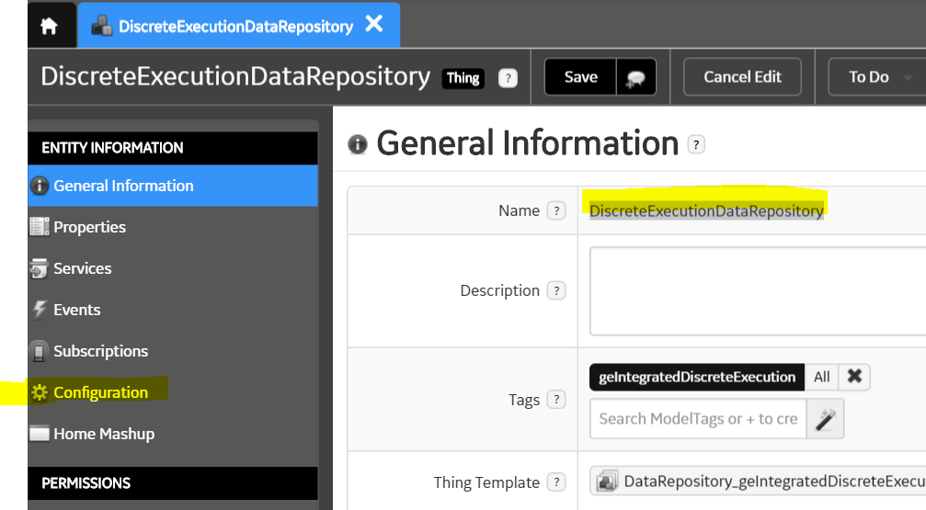

Fix the JDBC connection to point to the QA SQL Server

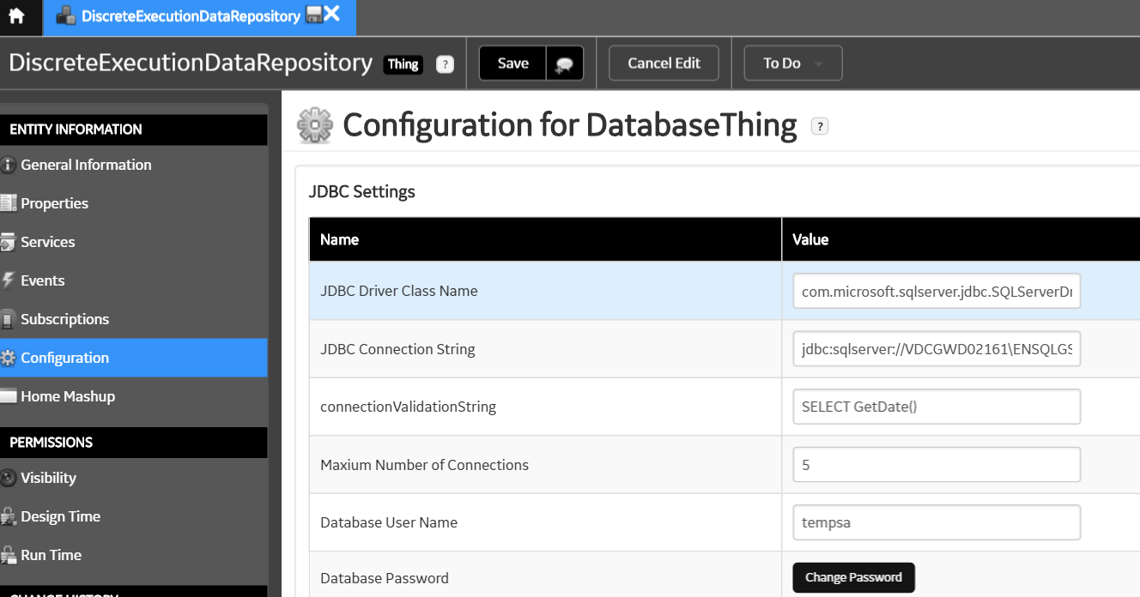

### SSRS URL Fix inside the PM Add on thingworx

For the Traveler Reports.

We need to set up the value for property reportUrl_Configuration_geIntegratedDiscreteExecution in DiscreteExecutionDataManager Thing as shown below to make the URL configurable.

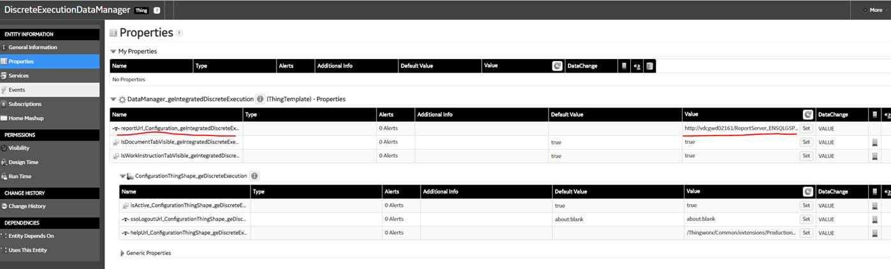

### Obtain the latest build

Verify the 3 mandatory artifacts that needed the Run Time Permissions for the “Operators” Group

These 3 Things (below highlighted) needs the explicit Run Time Access to the “Operators” user group.

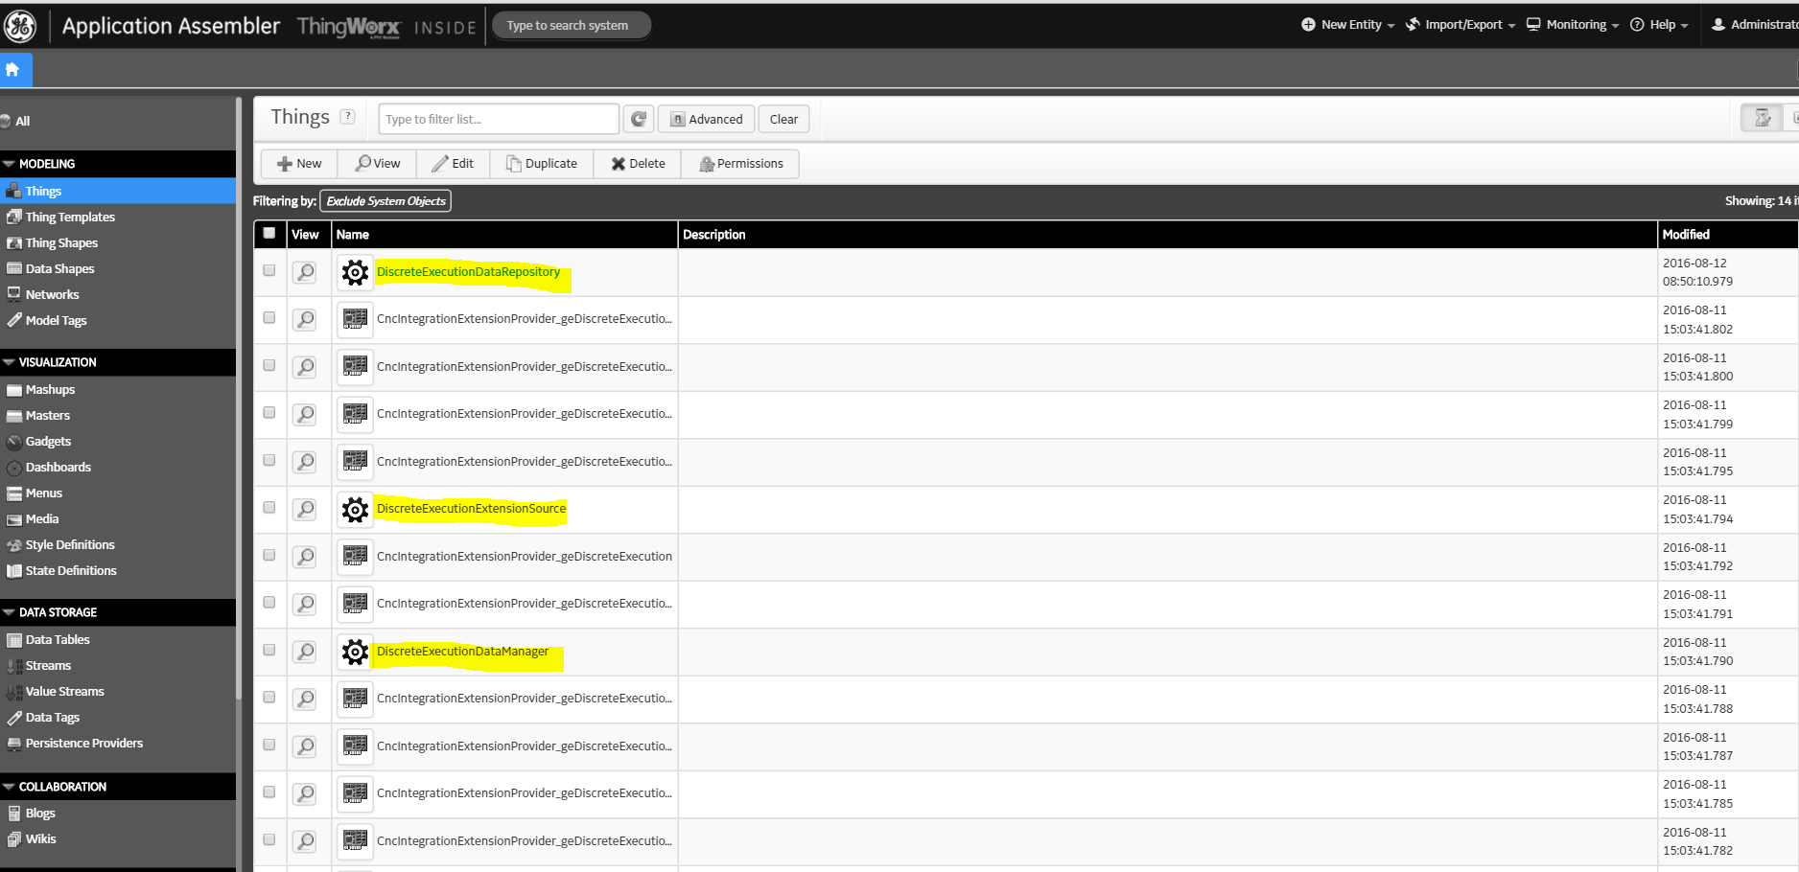

Typically, in the Run Time the Read and Execute, the first and the last radio button needs to be enabled for “Operators” user group like shown below, do this for all 3 things.

For the out of box things – you need to click the unlock icon at the right and add operators group if its not there and do the run time then.

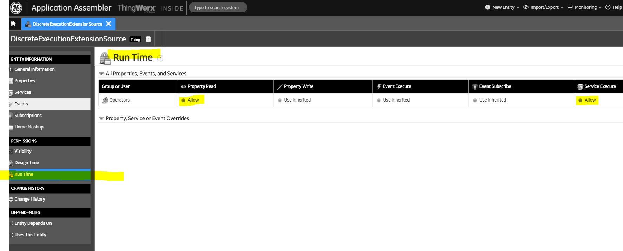

## For operator group

One extra step we need to do is to go to Composer > Menus > Give Permissions to Operator group for both the Menus i.e  **UserTopMenu_geDiscreteExecution** and  **UserMenu_geDiscreteExecution.**

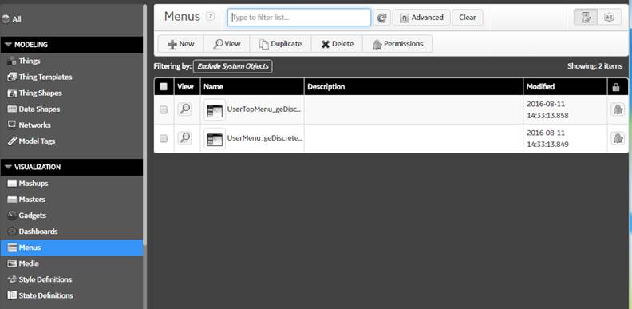

For both the menus, we need to set Allow permission for Service Execute only (as shown below)

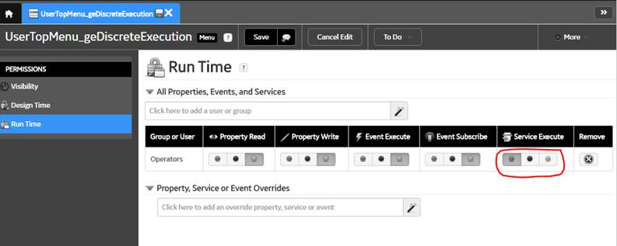

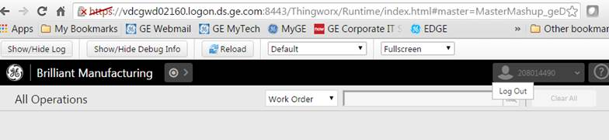

### Help files fix

Help Files

In the DiscreteExecutionDataManager properties

Make sure that we have the prefixed the GridSol-

/Thingworx/Common/extensions/**GridSol-**ProductionManagerExtension/ui/productionManagerHelp/Production%20Manager.htm

### Report Server URL for the Thingworx

Make sure the URL works before setting it up to the thingworx

<http://vdcgwd02161/ReportServer_ENSQLGSPDN01/Pages/ReportViewer.aspx?%2fReports%2fMESTravelerReport&LotOperationSegmentResponseId>=

In the DiscreteExecutionDataManager properties

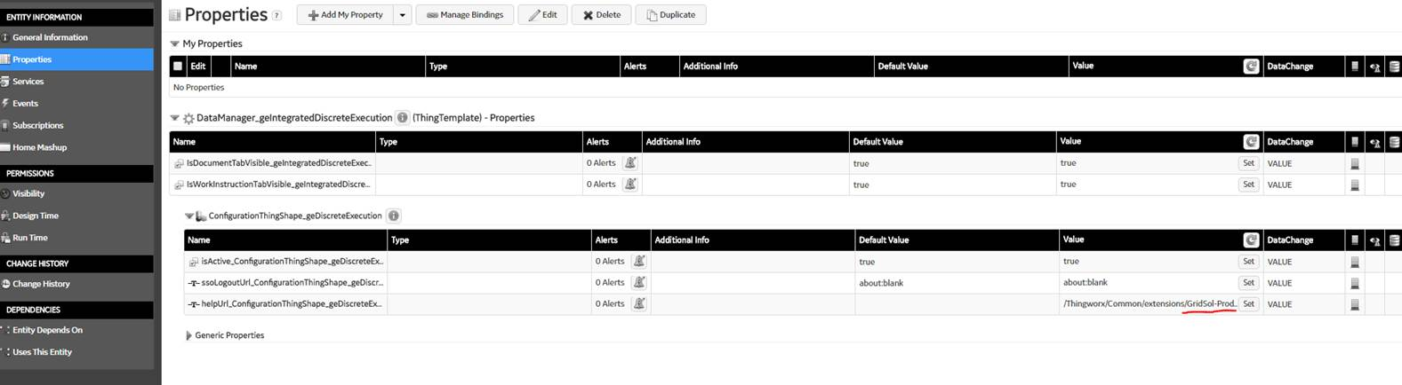

SUMMARY:

Get the artifacts from Bamboo (once its operational). For now we manually built the extensions on local environment and copied them to Installs folder on QA.

DEPLOYING ON QA SERVER:

1. Launch Thingworx.  First delete Thing entities: DiscreteExecutionDataRepository & DiscreteExecutionDataManager

2. Delete Grid Sol Prod manager Extension.

3. Import new extension from Installs folder.

4. Create the above two entities: Provide model tags , proper DB connection strings, username/pwd etc.

jdbc:sqlserver://VDCGWD02161\ENSQLGSPDN01;DatabaseName=SOADB

pmaddonuser/*******

5. Modify the Help file path in DiscreteExecutionDataManager (Thing) properties as below:



1. Finally Verify the changes.

### The FORM LOGIN for the Operators and GE GS users Thingworx

1. The Form Login Enablement
2. First go to the Security 🡺 Organization in Thingworx Composer and set the Logo for the Organization typically the PNG file of the GE
   1. You need to do this for Everyone in the Organization, select the Everyone
   2. Edit and under Login image upload the GE PNG file
      1. For the Home Mashup select the OperationSearchPage_geIntegratedDiscreteExecution
   3. For the mobile Mash up do the same
      1. OperationSearchPage_geIntegratedDiscreteExecution
3. Go to the Things, Go to the DiscreteExecutionDataManager thing
   1. Under the properties
   2. Go to ConfigurationThingShape_geDiscreteExecution
   3. Set the ssoLogoutUrl_ConfigurationThingShape_geDiscreteExecution
   4. The value will be something like this <http://vdcgwd02160.logon.ds.ge.com/Thingworx/FormLogin>
4. From now on the default Home page for login will be
   1. <http://vdcgwd02160.logon.ds.ge.com/Thingworx/FormLogin>
   2. No longer give the full URL for the operators search page

## Integration Configuration Check List

|  |  |
| --- | --- |
|  |  |
|  |  |
|  |  |
|  |  |